The 27th Da Dun Fine Arts Exhibition
Ref. No.
(Official use only)
of Taichung City
Entry Form I

Passport Name |  |  |  | Category
Residence address | □□□□□□（zip code）
Mailing Address | □same as residence address
Mailing Address | □□□□□□（zip code）
Contact Information | Tel：  Mobile：  E-mail：
Date of Birth | Year/Month/Date |  | Sex |  | Photo  (Please attach a recent photo of the entrant with his/her name printed on the back.)
ID Card/Passport Number |  |  | Occupation
Nationality |  |  | Highest Degree
Previous Exhibitions or Awards (list 2) | Year | Exhibition or Award with Prize
Declaration：
I fully understand and agree to abide by the Rules and Regulations of the 27th Da Dun Fine Arts Exhibition. The information filled in is true. If any infringement occurs, the organizer reserves the right to disqualify the submission.
Authorization：
I have read the X. point of the Rules and Regulations of the 27th Da Dun Fine Arts Exhibition carefully. I agree the organizer reserves the right to utilize the information and picture of artists' and artworks in any form, including for teaching, research, exhibition, filming, publishing, art event promotion, production of related DVDs, promotional materials, and website design. The rights mentioned above shall not be restricted by time, geographic location, number of times, and methods of use.I may be held personally liable for any copyright infringements arising from the use of materials, music, images, etc. in my artworks.

Signature of Entrant：
2022（Year） （Month） （Date）

The 27th Da Dun Fine Arts Exhibition
Ref. No.
(Official use only)
of Taichung City
Entry Form II

Title |  |  | Year of Creation
Size including the frame (cm) | H W D |  | Material
Printmaking | Type and Technique of Printing |  | Edition Number
Digital Art | the cloud UPL | Please fill in a valid short URL
Description (Please print a concise description of your work below－no more than 500 words.)

The 27th Da Dun Fine Arts Exhibition
Ref. No.
(Official use only)
of Taichung City
Entry Form III
Do not paste photos beyond the border.

Photo of the submitted work

⬧ Photo size: 8”x 10”, each with category/title/name/telephone noted on the back.

⬧ If more than one photo is attached, please stick the main photo on the top.

Schematic diagram of works floating

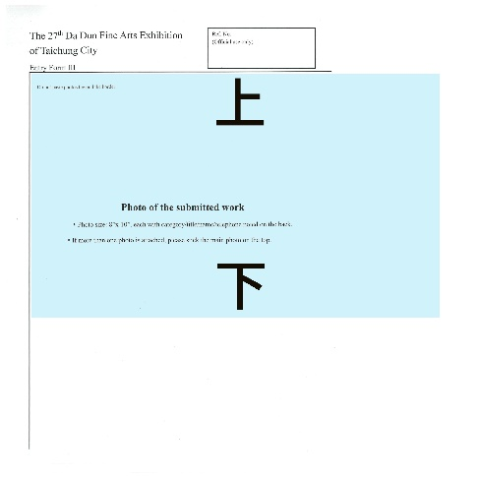
Straight

Horizontal

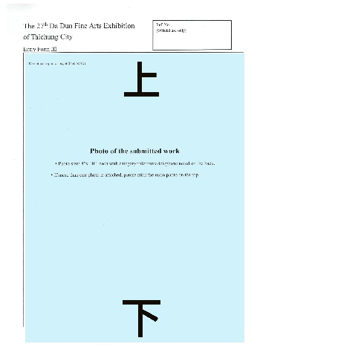

The 27th Da Dun Fine Arts Exhibition of Taichung City
Data Protection Declaration
According to the Paragraph 1, Article 8 of the Personal Data Protection Act (hereafter “the Act”), in order to protect your personal data, privacy and authority, your agreement below indicates that you have read and accepted the contents set forth in this agreement. Cultural Affairs Bureau of Taichung City Government(hereafter “the Bureau”)will collect, process and use your personal data for fair dealing when you submitted basic information.
- Purpose for gathering information:
To hold on the 27th Da Dun Fine Arts Exhibition of Taichung City, the Bureau will collect, process, and use your personal data to check eligibility.
- Types of information gathered:
Name, date of birth, ID card no., passport no.,address, telephone no., email address and so on.
- Handling and use of personal information:
- Utilizing period:
The time of the Da Dun Fine Arts Exhibition of competition, display and promotion.
- The region within which personal information:
Taiwan(R.O.C)
- Users and ways of using:
The Bureau and may use provided personal information for carrying out the Da Dun Fine Arts Exhibition, such as identity verification, contacting participants, providing competition and exhibition related service and information
- According to the Act, you are entitled to make the following requests:
- To check or review the collected data.
- To receive a photocopy of the collected data.
- To supplement or revise the collected data.
- To cease the collection, processing, use or deleting of the collected data.
- You may lose certain rights or benefits if you provide incomplete information.

Signature of Entrant：
2022（Year） （Month） （Date）

